5th Grade Summer Reading
Hello Fifth Grade!!!
This Summer I would like to help to keep your minds sharp by encouraging you to read! Please read for 20 minutes each day! I am requiring that you keep a reading log to help you to keep track of what you have read.
I have selected two great books. Both have won awards and when we return to school we have Reading Counts Quizzes for both! That will give you a jump start on your Reading Counts Goals!
Please read “Frindle” by Andrew Clements and “Esperanza Rising” by Pam Munoz Ryan. You will need to write a summary of both books (no less than three paragraphs please). Then choose one of these two books to create a Paper T-shirt Book Report to be presented to the class during the first week of September!
I have included the rubric to help you along your wonderful reading journey this summer!
Miss Grimm
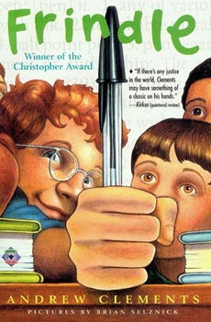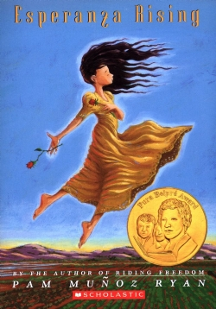

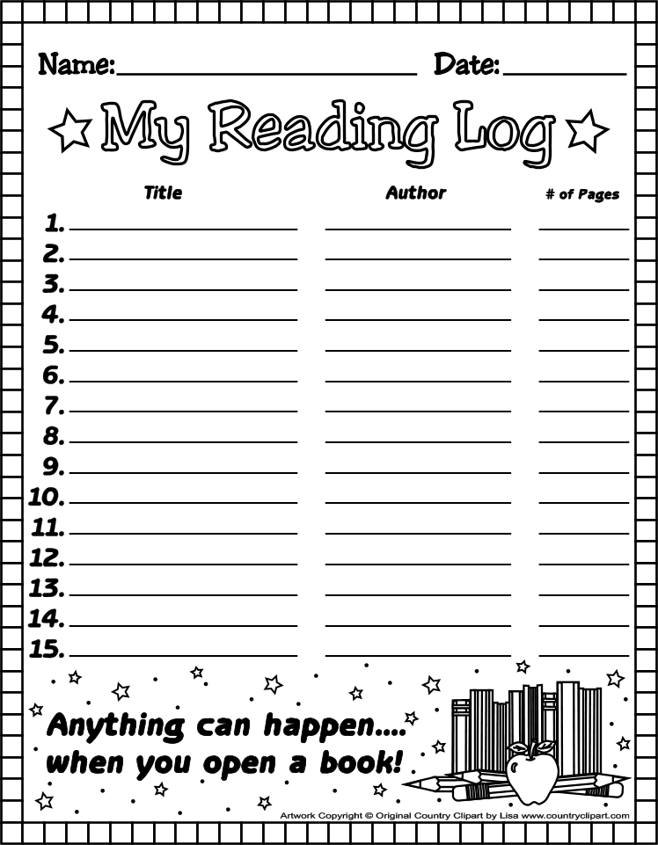
Rubric MadeUsing:
RubiStar ( http://rubistar.4teachers.org )
Paper T-shirt Book Report!
Teacher Name: Ms. Grimm
Student Name: ________________________________________
CATEGORY | 4 | 3 | 2 | 1
Front of t-shirt | The front contains the title, author slogan, and a descriptive illustration of the main conflict which is detailed. | The front contains the title, author, slogan, and an illustration of the main conflict with some details. | The front is missing either the title, author, or slogan. Your illustration is present but lacks detail. | The front is missing two + items. The illustration looks rushed and is missing many details.
Back of t-shirt | The back contains a descriptive illustration of a solution event which is detailed. | The back contains an illustration of a solution event. | The back contains an illustration that does not have enough details. | The back contains an illustration that does not reflect a solution to your book.
Grammar | There are no grammatical mistakes on the project. | There is 1 grammatical mistake on the project. | There are 2 grammatical mistakes on the project. | There are more than 2 grammatical mistakes on the project.
Attractiveness & Creativity | The project is exceptionally attractive and creative in terms of design, layout, and neatness. | The project is attractive and creative in terms of design, layout and neatness. | The project is a bit creative and acceptably attractive though it may be a bit messy. | The project is not creative and distractingly messy or very poorly designed. It is not attractive.
Summary | Your summary is at least three paragraphs with a focus on the conflict and solution illustrated as well as a description of the slogan. Shows relation to the book with details. | Your summary is at least three paragraphs with a focus on the conflict and solution illustrated as well as a description of the slogan. Shows relation to book. | Your summary is less than three paragraphs and lacks descriptive detail of conflict and solution illustrated. May not show relation to book with details. | Your summary is only one paragraph or less and is vague. No relation to book.
Summary Conventions | Your summary contains 2 or less errors in spelling, punctuation, and grammar. Your sentences vary in length, and is typed. | Your summary contains 3-4 errors in spelling, punctuation, and grammar. Your sentences are all about the same length. | Your summary contains 5-6 errors in spelling, punctuation, and grammar. Your sentences are the same length. | Your summary contains 7 or more errors in spelling, punctuation, and grammar. Your sentences are basic, and handwriting is hard to read.
Presentation | The presenter includes all major points and several details when describing his/her t-shirt. | The presenter includes all major points and 1-2 details when describing his/her t-shirt. | The presenter includes all major points when describing his/her t-shirt. | The presenter forgets major points when describing his/her t-shirt.
Listening | Listens intently. Does not make distractions. | Listens intently. Makes 1-2 inappropriate noises or movements. | Sometimes does not appear to be listening, but is not distracting. | Sometimes does not appear to be listening and makes distractions.
Date Created: June 07, 2011

